CE2007 Lab3 Assignment Sheet (to be submitted to NTULearn before next lab)

Name: Do Anh Tu Lab Group:SEP1 Date:

1. Section 6. Other than the procedures outlined in the introduction of Exception Handling, what other registers need to be noted when using the Exception Handling System in ARM Cortex M4F processor? Think globally…

We need to take note of these two registers: PRIMASK and BASEPRI

PRIMASK – Priority Mask Register is used to enable/disable all interrupts and exceptions globally (excepts NMI and hard fault). This disable interrupt indiscriminately, regardless of their priority level.

BASEPRI – Base Priority Mask Register is used to selectively disable the interrupts based on a base priority level. This BASEPRI has 8 bit value that support 255 priorities and will disable any interrupts with priority level equal or less than the set value.

Note that in Cortex M4F, the bigger priority number, the lower the priority is. E.g. Priority 0 > priority 1. By default, these two registers value are 0x0 (no interrupts are disabled and no effect from BASEPRI). For a more robust prioritising of interrupts, better to use BASEPRI.

1. Section 6.2. The bump switch used in the lab is shown below. Pin 1 and 3 of the bump switch are connected to the MSP432. Draw the internal circuit of the bump switch and describe how the MSP432 GPIO can be used to detect that the switch is closed?

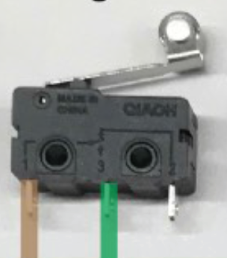

1. Section 6.3. Write down the GPIO configuration used for pins connected to pin 3 of the Bump switch.
2. Section 6.3. Illustrate with detail working and APIs used how systick timer is configure to interrupt the system at 1000Hz frequency.
3. Section 6.4. In the Simple motor project, the api used to move the motor forward is Motor_ForwardSimple(uint16_t duty, uint32_t time), where time is number of 10ms units, i.e. if time=2, motot will run for 2ms. Show and explain the code in the function that enable this 10ms unit timing.
4. Section 6.5. Reference to PWM_Init1() in PWM.c, what is the base clock used to increment the counters in Timer_A0? Show the details of how this base clock of Timer_A0 is derived.
5. Section 6.5. What is the PWM frequency generated to the motor? illustrate with detail working.
6. Section 6.5. Is interrupt mechanism used in the PWM generation via Timers?
7. Section 6.5. What is the IRQ number corresponding to the interrupt used by Timer_A1 in Lab3_TimerCompare_Motor project use? What is the corresponding Exception number?